**5-Program to implement Remote Method Invocation.**

***Remote Method Invocation (RMI)*** is a Java-based mechanism that allows one Java virtual machine (JVM) to invoke methods on objects located in another JVM, which can be running on a different physical or networked machine. RMI enables distributed computing by providing a way for objects in one JVM to interact with objects in another JVM as if they were local, while abstracting away the complexities of network communication.

**C++ code:**

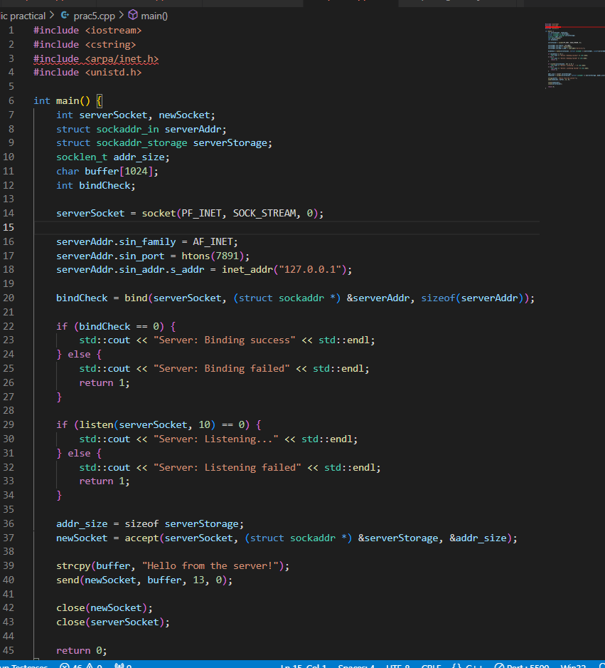

**OUTPUT:**



